[](http://www.google.ca/url?sa=i&rct=j&q=&esrc=s&source=images&cd=&cad=rja&uact=8&ved=0ahUKEwjxgIKJuNDXAhXk0FQKHeUZBJgQjRwIBw&url=http://hosted.verticalresponse.com/710854/5eab2ccec3/TEST/TEST/%7bVR_UNSUB_LINK%7d&psig=AOvVaw1YPaAzN1vYeYO76RbDskXF&ust=1511380149236071) CTK Resource Corner

[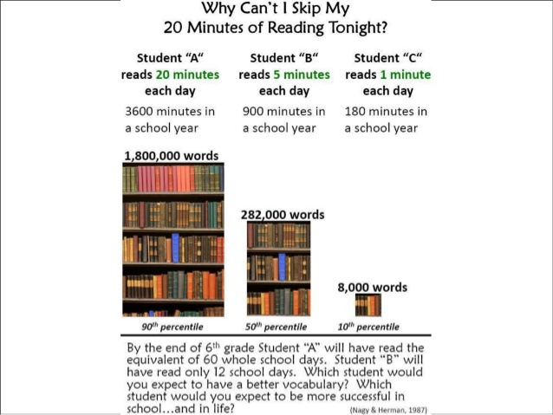](https://www.google.ca/url?sa=i&rct=j&q=&esrc=s&source=images&cd=&cad=rja&uact=8&ved=2ahUKEwjD0dO9hqrfAhVq74MKHXUcB1MQjRx6BAgBEAU&url=https://www.slideshare.net/Donalynm/why-cant-i-skip-my-20-minutes-of-reading-tonight&psig=AOvVaw23-HbxyQZ44gqKu8JJMnHi&ust=1545245571434800)