Guided Reading News

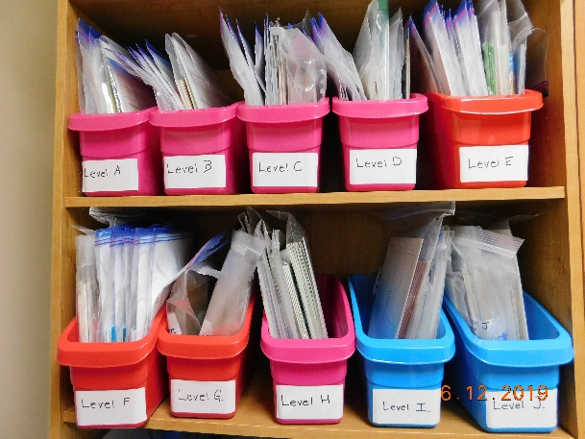
We are excited to be building a Guided
Reading library at Christ the King School for the
2019-2020 school year! Students and teachers from
Grade K-4 can access a variety of fiction and
non-fiction reading material. Book Fair funds and
school funds were used to purchase reading
material.

There are many benefits to Guided Reading:
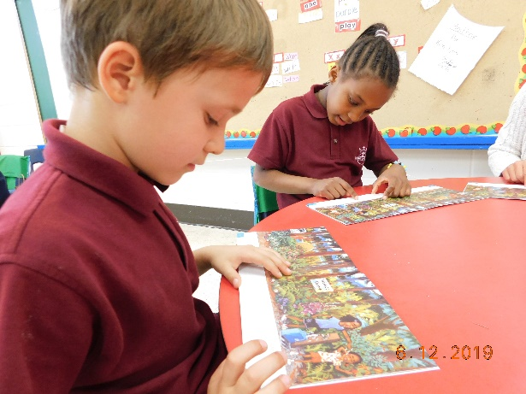
- Students develop as individual readers while teachers are available for support and scaffolding.
- Students learn skills and strategies that will allow them to read difficult texts independently.
- Students experience success in reading for meaning.
- Students receive more individualized teaching time.
- Teachers can use good literature to strengthen reading comprehension strategies.

