[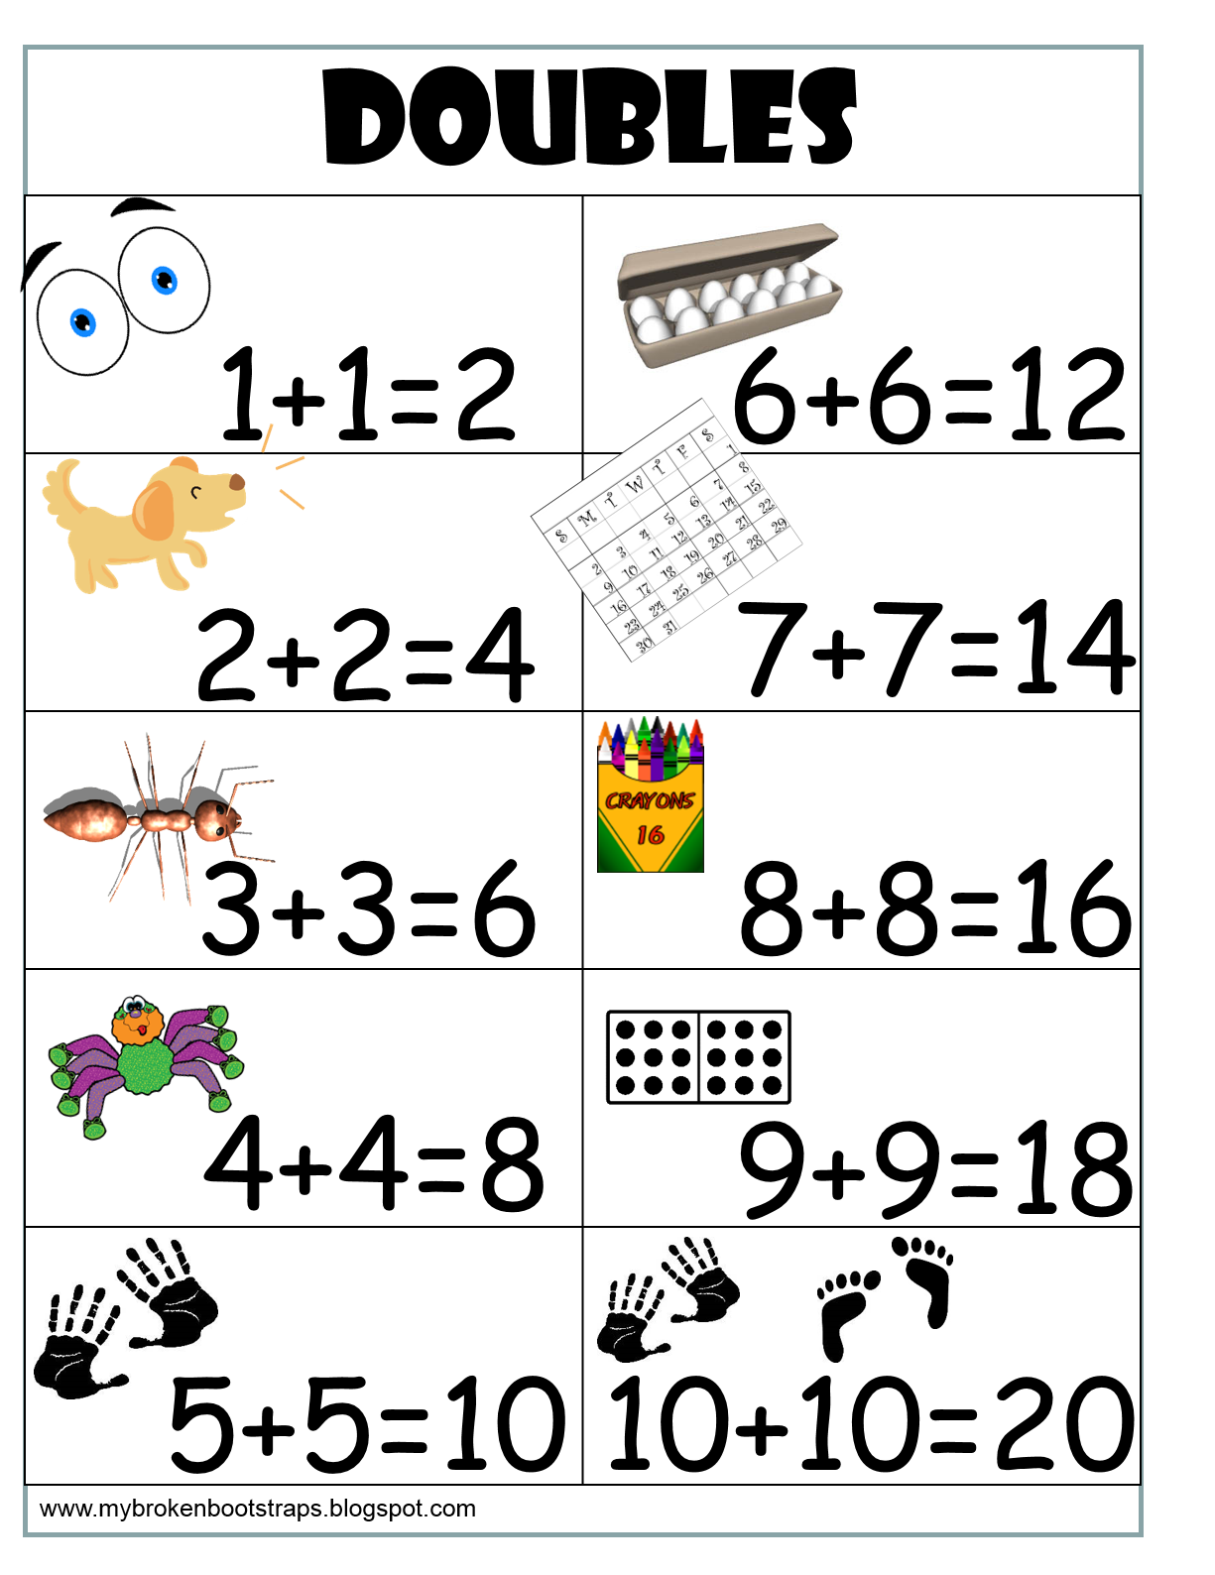](http://www.google.ca/url?sa=i&rct=j&q=&esrc=s&source=images&cd=&cad=rja&uact=8&ved=&url=/url?sa%3Di%26rct%3Dj%26q%3D%26esrc%3Ds%26source%3Dimages%26cd%3D%26ved%3D%26url%3Dhttps%3A%2F%2Fwww.pinterest.com%2Fpin%2F294141419397226035%2F%26psig%3DAOvVaw1ScxjPiWI4FR3hVauibJDz%26ust%3D1574267426296410&psig=AOvVaw1ScxjPiWI4FR3hVauibJDz&ust=1574267426296410)

[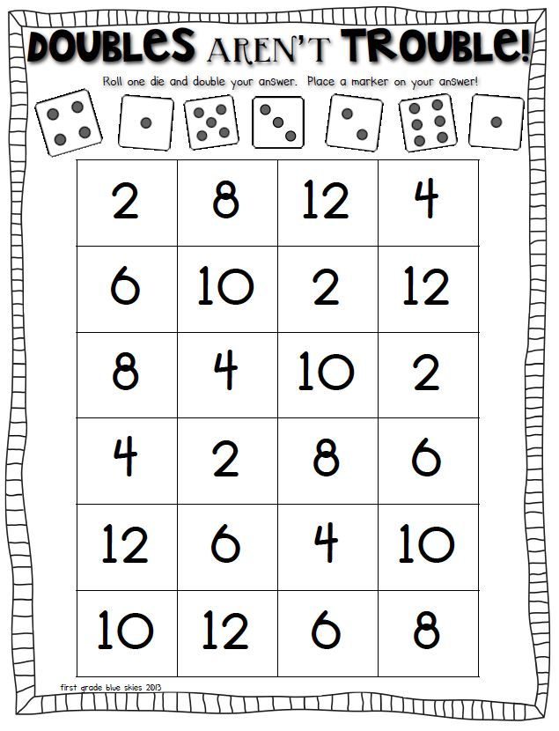](https://www.google.ca/url?sa=i&rct=j&q=&esrc=s&source=images&cd=&ved=&url=https://www.pinterest.com/pin/179369997639716819/&psig=AOvVaw3_EZLKQp_dOOUfTYZSi7kz&ust=1574267468650527)

[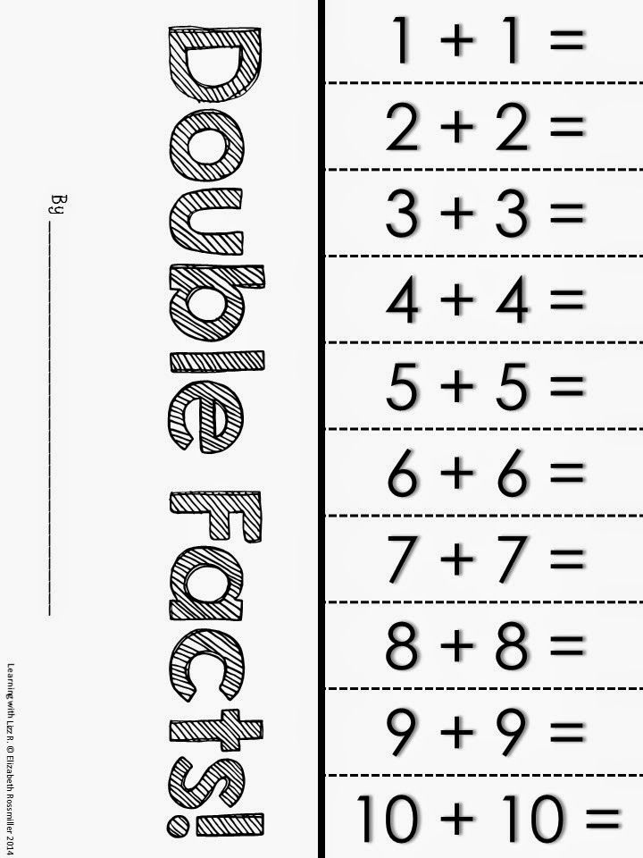](http://www.google.ca/url?sa=i&rct=j&q=&esrc=s&source=images&cd=&cad=rja&uact=8&ved=&url=/url?sa%3Di%26rct%3Dj%26q%3D%26esrc%3Ds%26source%3Dimages%26cd%3D%26ved%3D%26url%3Dhttps%3A%2F%2Fwww.pinterest.cl%2Fpin%2F229120699769943083%2F%26psig%3DAOvVaw3_EZLKQp_dOOUfTYZSi7kz%26ust%3D1574267468650527&psig=AOvVaw3_EZLKQp_dOOUfTYZSi7kz&ust=1574267468650527)

[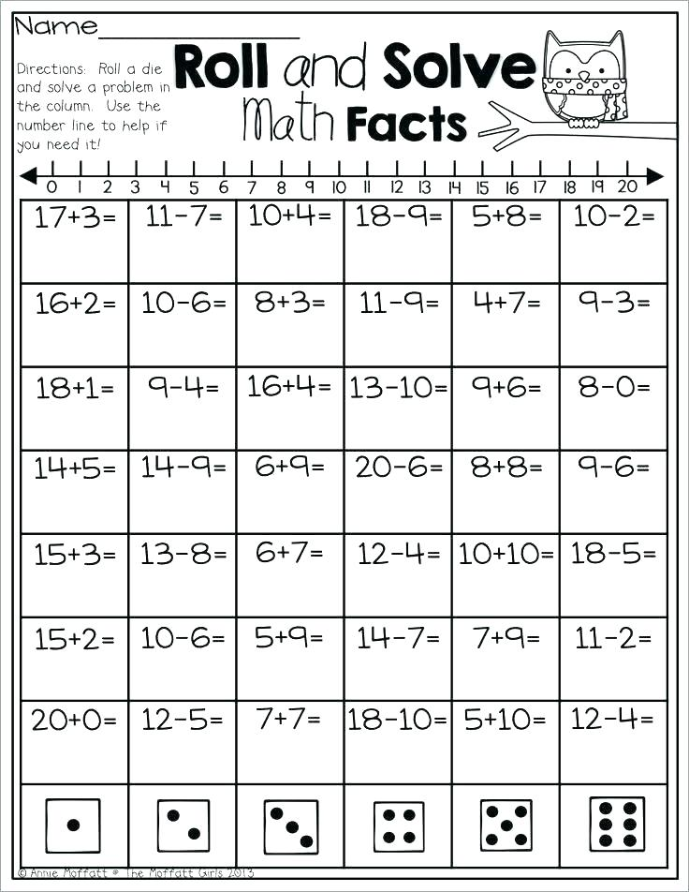](https://www.google.ca/url?sa=i&rct=j&q=&esrc=s&source=images&cd=&ved=&url=https://ashafrance.org/double-math-facts-worksheets/&psig=AOvVaw3_EZLKQp_dOOUfTYZSi7kz&ust=1574267468650527)

[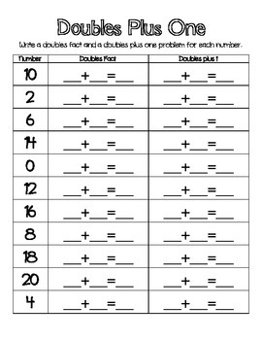](http://www.google.ca/url?sa=i&rct=j&q=&esrc=s&source=images&cd=&cad=rja&uact=8&ved=&url=/url?sa%3Di%26rct%3Dj%26q%3D%26esrc%3Ds%26source%3Dimages%26cd%3D%26ved%3D%26url%3Dhttps%3A%2F%2Fwww.teacherspayteachers.com%2FBrowse%2FSearch%3Adoubles%2520facts%26psig%3DAOvVaw3_EZLKQp_dOOUfTYZSi7kz%26ust%3D1574267468650527&psig=AOvVaw3_EZLKQp_dOOUfTYZSi7kz&ust=1574267468650527)